Multi-Sided Platform Architecture—a digital business model where a platform connects two or more different groups of users and creates value by helping them interact.
A simple way to understand it is:
The platform itself may not provide the main product or service. Instead, it creates the environment where different groups can find, communicate, transact, and exchange value.
For example, Uber does not need to own every car. It connects riders who need transportation with drivers who provide transportation.

1. Two-Sided Market Mechanics
What does it mean?
A two-sided market connects two distinct groups that need each other.
Typical combinations include:
- Buyers ↔ Sellers
- Drivers ↔ Riders
- Guests ↔ Hosts
- Students ↔ Tutors
- Freelancers ↔ Clients
- Restaurants ↔ Customers
The platform acts as the intermediary that makes the interaction easier.
Example: Uber
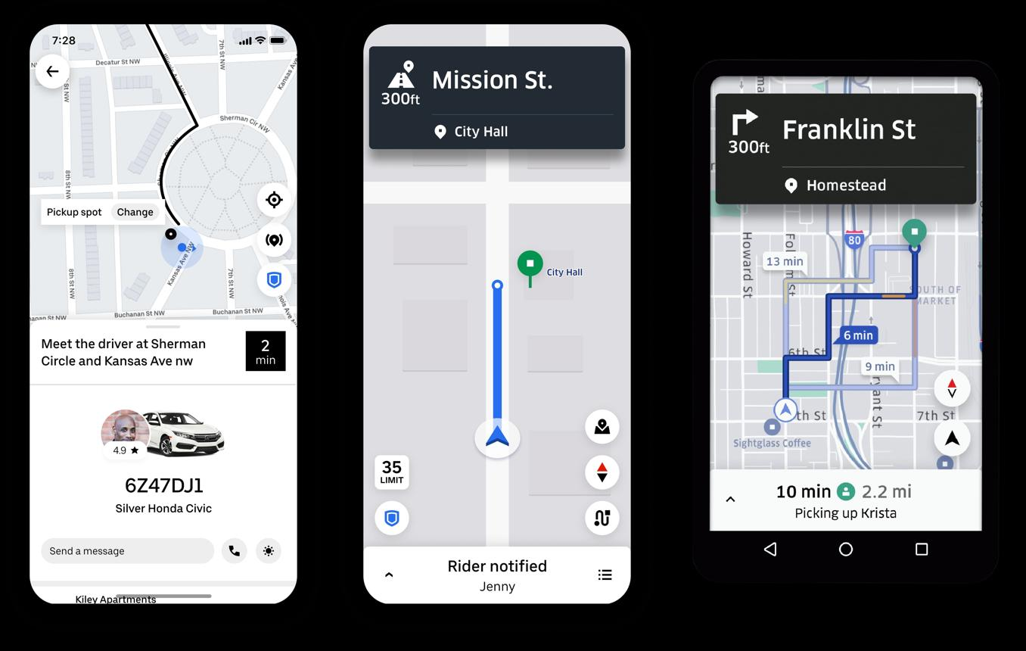
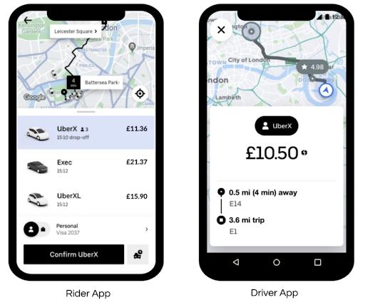


Side 1 – Riders
- Need transportation.
- Open Uber.
- Enter their destination.
- Request a ride.
Side 2 – Drivers
- Want passengers and income.
- Use the Uber Driver app.
- Receive ride requests.
- Pick up passengers.

Uber – Platform
- Matches riders with drivers.
- Calculates fares.
- Processes payments.
- Provides GPS/navigation.
- Collects ratings.
- Handles communication.
The value exchange
Rider → Uber → Driver
Rider needs a ride → Uber finds a driver → Driver provides the ride → Rider pays.
So Uber's primary role is connecting the two sides efficiently.
2. Network Effects
What does it mean?
A network effect occurs when a platform becomes more valuable as more users participate.
There are two important types.
A. Cross-Side Network Effect
One group becoming larger makes the platform more valuable to another group.
Uber example
Imagine Uber has:
100 drivers + 1,000 riders
Drivers have many potential customers.
Now Uber grows to:
10,000 drivers + 500,000 riders
More riders create more opportunities for drivers to earn money.
At the same time, more drivers mean riders can potentially get:
- Faster matching
- More available vehicles
- Better geographic coverage
- Potentially shorter waiting times
So:
More drivers → more value for riders
More riders → more value for drivers
This is a cross-side network effect.
B. Same-Side Network Effect
The number of users on the same side affects the value experienced by other users on that side.
For example, consider LinkedIn.
More professionals joining LinkedIn can create:
More professionals → more professional connections → more networking opportunities
Similarly:
More employers → more job opportunities → more value for job seekers
However, same-side effects are not always positive. For example, if too many sellers compete on the same marketplace, individual sellers may face more competition.
3. Platform Orchestration
What does it mean?
Platform orchestration means managing and coordinating all the activities that allow the different sides of the platform to interact successfully.
Think of the platform as a digital conductor of an orchestra.
It does not necessarily perform every activity itself. Instead, it coordinates everyone.

Example: Airbnb
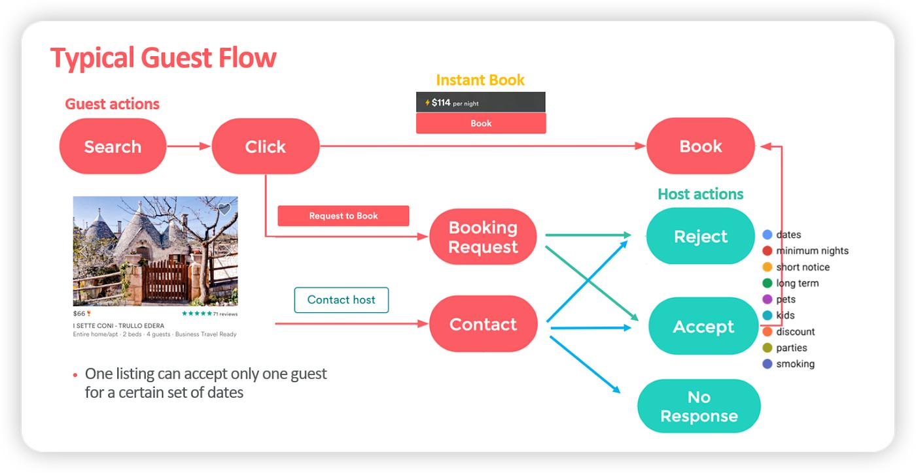
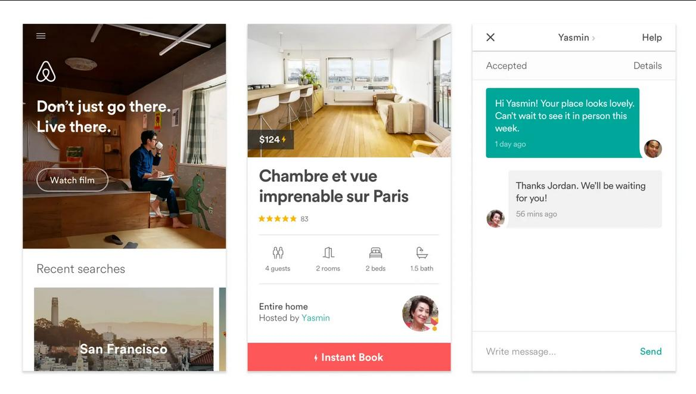
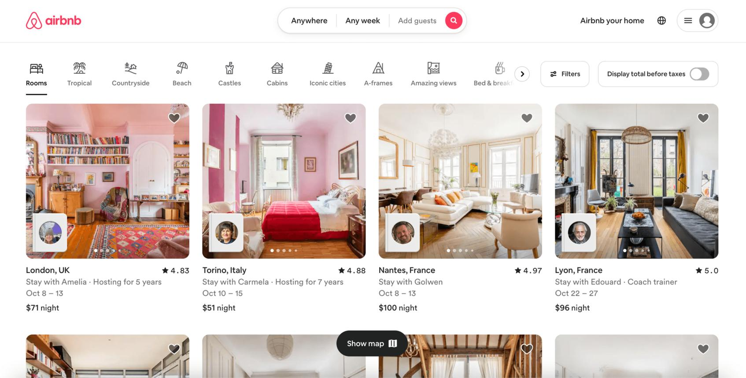
Airbnb connects:
Hosts ↔ Airbnb ↔ Guests
Airbnb has to coordinate many things:
Activity | How Airbnb helps
Matching | Guests search for suitable accommodation
Pricing | Hosts can use pricing tools
Booking | Guests make reservations
Payment | Airbnb facilitates payments
Reviews | Guests and hosts review each other
Trust | Identity verification and platform policies
Communication | Messaging between host and guest
Dispute handling | Platform processes certain complaints
Recommendations | Algorithms suggest properties

Without this orchestration, the marketplace would become difficult to use.

Example
Suppose a guest searches:
"3-bedroom apartment in Singapore for 4 people, 5 nights."
Airbnb's platform can filter and rank properties based on:
- Location
- Price
- Availability
- Number of bedrooms
- Reviews
- Amenities
- Guest preferences
The platform is therefore orchestrating the interaction between the guest and host.

4. Match-Making Algorithms
This is an important part of platform orchestration.
A platform uses algorithms to determine:
Who should be connected with whom?
Uber example
A rider requests a trip from:
Orchard Road → Changi Airport
Uber's system considers factors such as:
- Driver location
- Driver availability
- Destination
- Estimated travel time
- Traffic conditions
- Ride type
The system then identifies an appropriate driver.
So:
Rider request → Algorithm → Suitable driver
The algorithm reduces the amount of time users would otherwise spend searching manually.

5. Automated Pricing
Platforms can also use technology to adjust prices or provide pricing recommendations.
Example: Airbnb
Suppose there is a major event in Singapore.
Normally:
Hotel/room demand = moderate
During the event:
Hotel/room demand = very high
Hosts may increase their prices because demand has increased.
Similarly, platforms can use data about:
- Demand
- Availability
- Location
- Season
- Historical bookings
- Events
to support pricing decisions.
Uber example
Uber has also used dynamic pricing, where fares can change based on factors such as demand and available drivers.
For example:
Normal demand → normal fare
Very high demand + limited drivers → higher fare
The important concept for students is:
Digital platforms can use data and algorithms to coordinate supply and demand.

6. Digital Trust Mechanisms
One major problem with online marketplaces is:
"How do I trust someone I don't know?"
Platforms solve this using various trust mechanisms.
Example: Airbnb
A guest may think:
"How do I know this host is legitimate?"
Airbnb can provide mechanisms such as:
- User profiles
- Reviews
- Ratings
- Identity-related verification
- Booking records
- Payment protection mechanisms
- Platform policies
Similarly, a host may ask:
"How do I know this guest is trustworthy?"
The platform's reputation and review system helps reduce uncertainty.

7. Market Champions
The slide gives three excellent examples.
A. Uber – Mobility

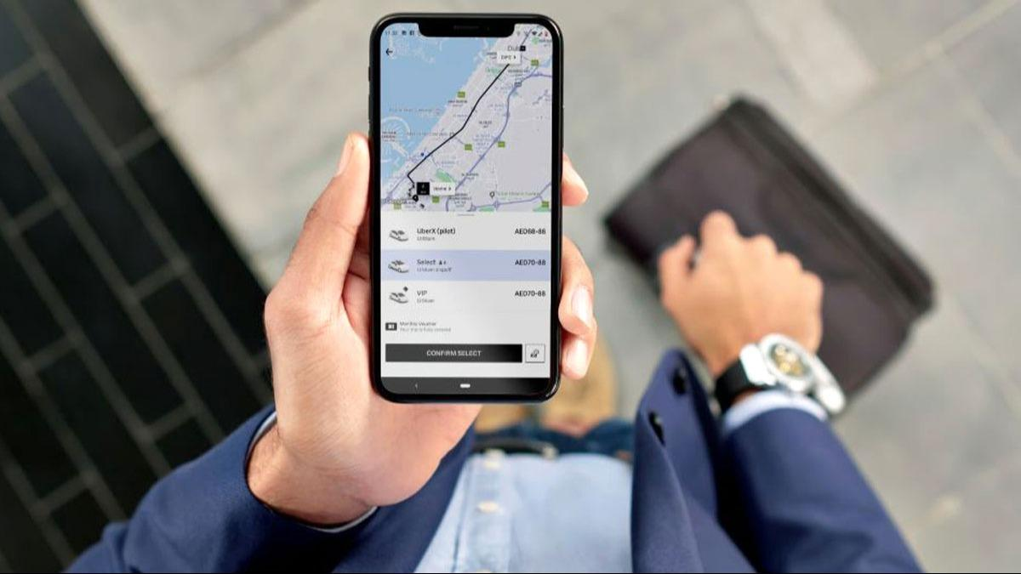

Platform sides
Drivers ↔ Uber ↔ Riders
Value created
Drivers get:
- Access to customers
- Income opportunities
- Digital tools
Riders get:
- Access to transportation
- Driver matching
- Digital payment
- Trip tracking
Platform advantage
Uber's value comes largely from connecting and coordinating the two sides.

8. Airbnb – Hospitality

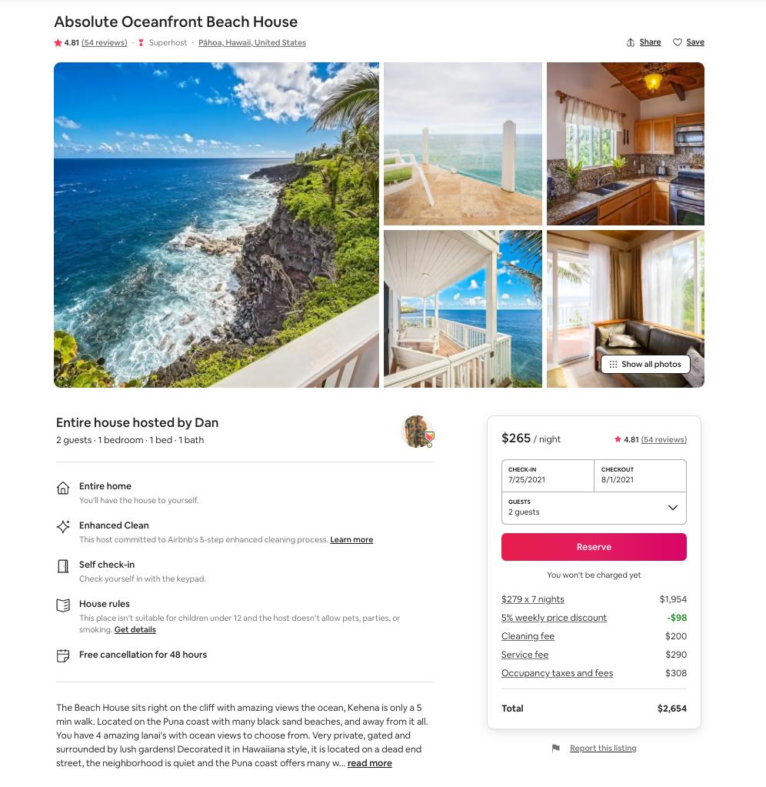

Platform sides
Hosts ↔ Airbnb ↔ Guests
Hosts provide:
- Houses
- Apartments
- Rooms
- Other accommodation
Guests provide:
- Demand
- Payments
- Reviews
Airbnb provides:
- Search
- Matching
- Booking
- Payment
- Communication
- Reviews
- Trust mechanisms
Therefore:
Airbnb creates a marketplace rather than owning all the accommodation listed on its platform.

9. Amazon Marketplace – E-Commerce
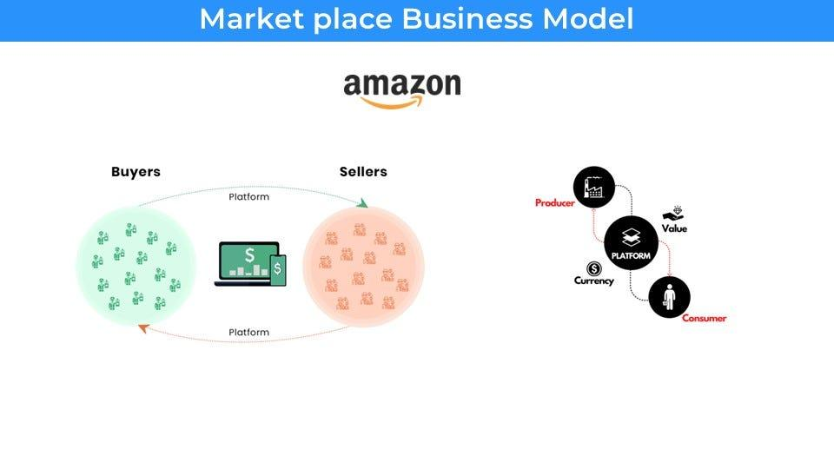
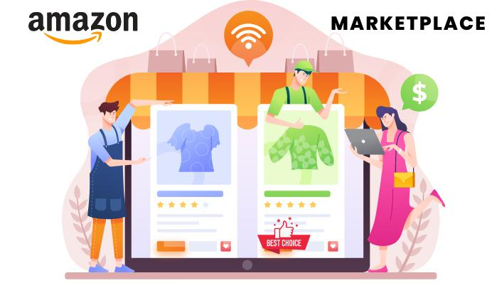

Amazon Marketplace connects:
Sellers ↔ Amazon ↔ Buyers
Seller side
Businesses and individuals can list products.
Buyer side
Customers search for and purchase products.
Amazon's role
Amazon provides infrastructure such as:
- Product listings
- Search
- Recommendations
- Payment
- Reviews
- Order management
- Logistics/fulfilment options
- Seller tools
Network effect
More sellers can mean:
More products → more choices for customers
More customers can mean:
More potential buyers → more opportunities for sellers
This can create a reinforcing cycle:
More sellers → more products → more customers → more sales opportunities → more sellers
10. Feedback Loops and Data Flow
This is another important part of the diagram.
Every interaction on a digital platform generates data.
For example, on an e-commerce platform:
Customer searches for running shoes
↓
Views products
↓
Adds one to cart
↓
Purchases
↓
Gives a rating
↓
Platform collects data
↓
Algorithm improves recommendations
↓
Customer receives more relevant products
This creates a feedback loop.
Example: Netflix
A simplified version is:
Watch movie → Netflix learns preferences → recommends similar movie → user watches → more data → better recommendations
The platform becomes better at personalization as it collects more interaction data.

11. Value Creation vs. Value Capture
This distinction is particularly useful for students studying digital business.
Value Creation
The platform creates value by helping users do something more easily.
For example, Amazon helps:
Buyer find seller + Seller find buyer
Value Capture
The platform generates revenue from the activity.
For example, a marketplace may generate revenue through:
- Transaction fees
- Commissions
- Advertising
- Subscription fees
- Premium services
So:
Value Creation = How the platform creates benefits for users
Value Capture = How the platform earns money from those activities
12. Putting Everything Together: Uber Example
Step 1 – Two sides
Drivers ↔ Riders
Step 2 – Platform
Uber provides the digital infrastructure connecting them.
Step 3 – Matchmaking
The algorithm identifies an available driver for a rider.
Step 4 – Transaction
The rider books the ride and pays digitally.
Step 5 – Trust
Both sides can rate each other.
Step 6 – Data
Uber collects information about:
- Trips
- Locations
- Demand
- Driver availability
- Ratings
- User behaviour
Step 7 – Feedback
The data can be used to improve:
- Matching
- Estimated arrival times
- Recommendations
- Pricing
- Platform operations

Step 8 – Network effect
More riders can attract more drivers.
More drivers can improve availability for riders.
Step 9 – Revenue
The platform captures value through its business model, including fees associated with transactions.

Concept | Simple Meaning | Real-World Example
Two-Sided Market | Connect two groups that need each other | Uber: drivers ↔ riders
Network Effect | More users can increase platform value | More Uber drivers → better availability
Platform Orchestration | Coordinate interactions between users | Airbnb manages search, booking, payment and reviews
Matchmaking | Algorithm connects suitable users | Uber matches riders with drivers
Automated Pricing | Technology supports dynamic/recommended prices | Ride/accommodation pricing based on demand
Digital Trust | Mechanisms reduce uncertainty between strangers | Ratings, reviews, verification
Feedback Loop | User activity generates data that improves the platform | Amazon recommendations
Value Creation | Benefits created for platform participants | Amazon connects buyers and sellers
Value Capture | How the platform makes money | Commission, transaction fees, advertising
Market Champion | Major real-world platform example | Uber, Airbnb, Amazon

